3MTT Data Science Report on COvid-19 Dataset Analysis
By Opeyemi Adebiyi
Cohort 2 Fellow
Fellow ID: FE/23/35118215

Objective
The goal of this analysis was to explore the COVID-19 dataset and conduct data cleaning, perform exploratory data analysis (EDA), and develop predictive model to forecast COVID-19 trends.
Data Sources
Link to dataset: https://www.kaggle.com/datasets/imdevskp/corona-virus-report
The link contain the following datasets used for the analysis:
- covid_19_clean_complete.csv: The file contains the cumulative count of confirmed, death and recovered cases of COVID-19 from different countries from 22nd January 2020
- country_wise_latest.csv: contains country-wise latest data.
- day-wise.csv: contains Day wise nunmber of cases.
- Full_grouped.csv: Date and country wise data
- Usa_county_wise.csv: Cumulative count of confirmed and deaths reported in USA
- Worldometer.csv: Data from worldmeter website.
Steps followed
- Library Importation
The libraries to be used for the analysis were imported in this step:


- Data Importation
The datasets were imported using pandas for structured data manipulation. The code snippet for importing the data:
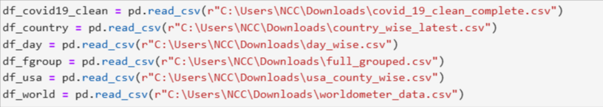

- Data Cleaning
Missing Values: Missing values were identified using isnull() and handled using fillna() for non-critical columns. For instance, the dataframe below was tested for null values and returned 34404 null values in the Province/State column, then filled with empty string in the next line of code.
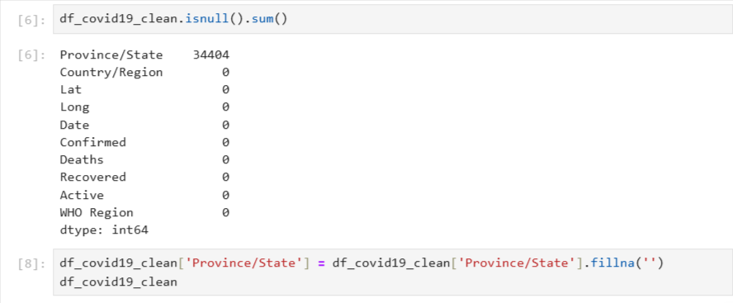
Data Types: Ensured consistent data types for dates and numeric fields using pd.to_datetime(). For instance the Date column of the covid19 dataset was set to the appropriate data type using the pandas method to_datetime().
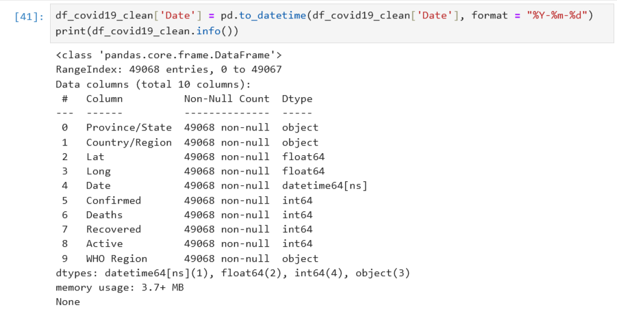

Duplicates: Ensured that there were no duplicates in the datasets.
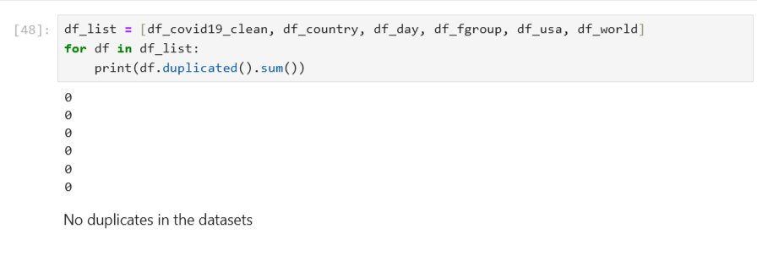

Renaming Columns: Renamed some columns to ensure consistency in the dataset.

- EXPLORATORY DATA ANALYSIS (EDA)

Total confirmed cases from each country
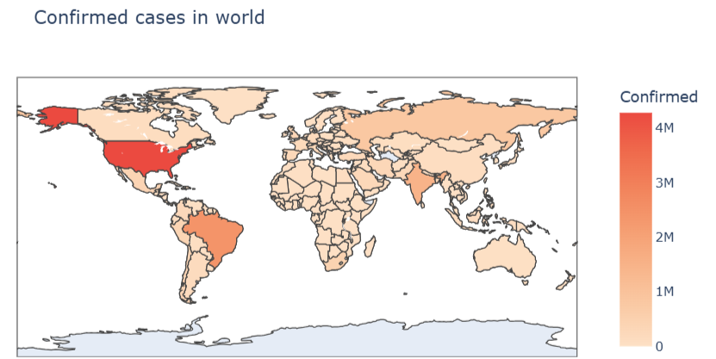
The US has the most confirmed cases about 4.3M, Brazil comes second with about 2.5M confirmed cases, and India with about 1.5M confirmed cases.
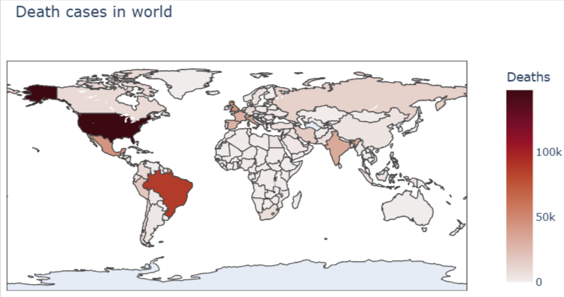
The US has the highest number of death cases with 148K cases, followed by Brazil with 87.6K, UK with 45.8K, Mexico with 44K and Italy with 35K death cases.
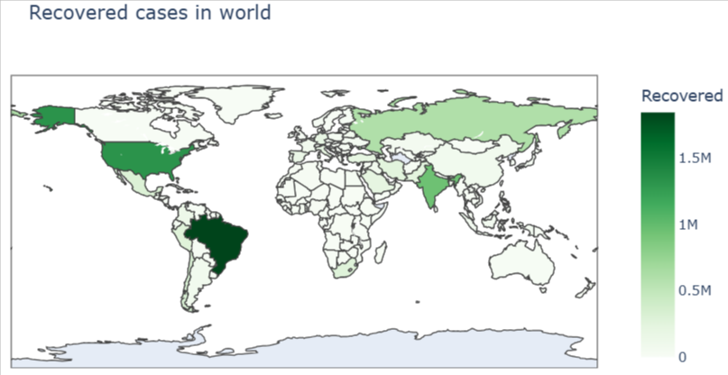

Brazil has the most recorded recovered cases of 1.85M, the US with 1.33M, India with 951.2K and Russia with 602.3K recovered cases.

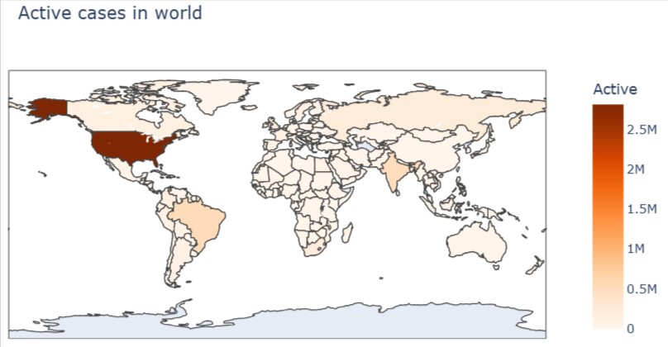

The US has the highest active cases with 2.82M, followed by Brazil with 508K and India with 495.5K active cases.

INSIGHTS DERIVED FROM THE INTERACTIVE MAP FINDINGS
- Severe impact on the US. The US leads in confirmed cases, deaths, and active cases. This could be attributed to, High testing rates revealing more cases, Early widespread community transmission, Variability in public health measures across states.
- High motality rates in western countries. Countries like the US, Brazil, UK, Mexico, and Italy have significant death counts. This could be attributed to possible strain on healthcare systems or delayed interventions and demographic factors such as higher populations of elderly individuals or pre-existing health conditions.
- Brazil’s recovery strength. Despite being second in confirmed cases, Brazil has the most recorded recoveries (1.85M). This indicates effective recovery mechanisms or natural progression of the disease. However, the country also reports the second-highest active cases (508K), suggesting an ongoing battle with transmission control.
- India’s emerging crisis. India ranks third in confirmed cases but has significant active cases (495.5K) with a large population. This suggests a potential for a larger outbreak due to high population density, and highlights the need for aggressive interventions to prevent escalation.

Plot of Cases (Confirmed, Deaths, Active) over time
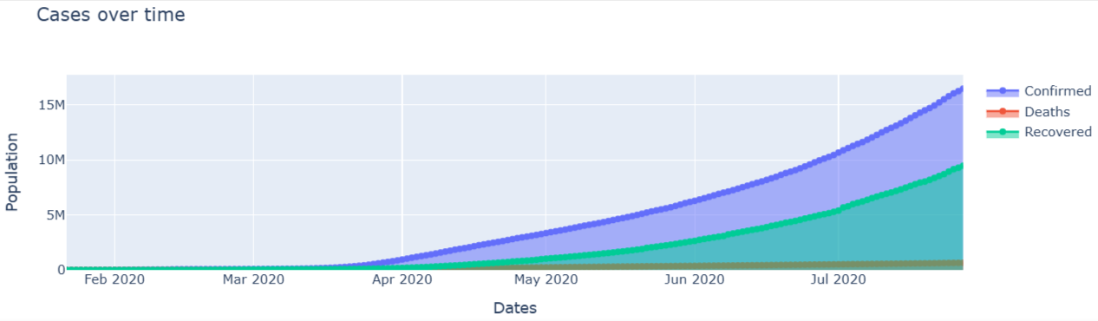
Observations:
- There is a sudden major increase in Confirmed cases from April upwards and might be due to the following: Increased testing capacity, Community transmission, and Spread in densely populated areas like US, India etc.
- Till July 27th, there were around 16.48M confirmed cases, 9.46M recovered cases and 654K deaths in world.

Geospatial Spread of covid 19
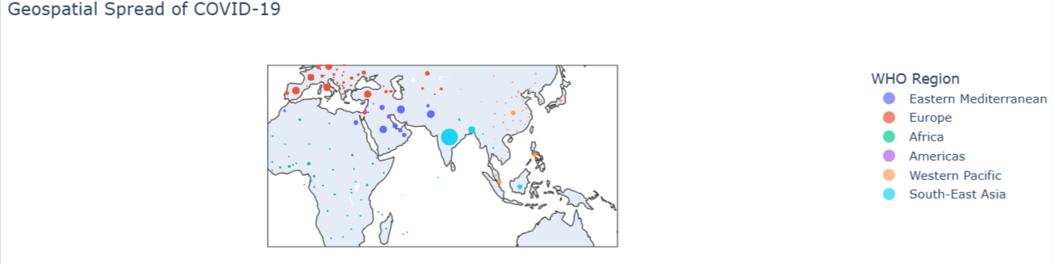

Observations:
- Larger bubbles, indicating higher case counts, are concentrated in regions such as Europe, the Americas, and South-East Asia. This suggests that these regions experienced the highest COVID-19 outbreaks.
- Africa, and Western Pacific show relatively smaller bubbles, suggesting lower case counts in many areas.
INSIGHTS DERIVED FROM THE GEOSPATIAL SPREAD OF COVID 19:
High Case Concentrations in Europe, the Americas, and South-East Asia. Larger bubbles in these regions indicate significant outbreaks, likely due to:
  - Higher population densities, particularly in urban centers.
  - Extensive international travel hubs acting as vectors for the virus's rapid spread.
  - Delayed or inconsistent implementation of containment measures in some countries.
Lower Case Counts in Africa and Western Pacific. Smaller bubbles suggest comparatively fewer cases, potentially due to:
  - Early and strict containment measures in some countries (e.g., New Zealand, Vietnam).
  - Younger population demographics in Africa reducing severe outcomes and potentially limiting detected cases.
  - Limited testing and reporting capacity in some regions, leading to underreporting.
Time-Series Trends: Daywise Dataset
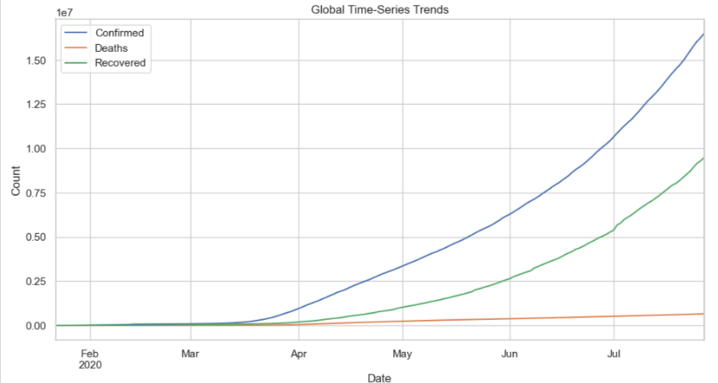
- Confirmed Cases (Blue Line): The number of confirmed cases shows an exponential increase starting from mid-march 2020. By July 2020, the confirmed cases have crossed 15 million globally, which highlights the rapid spread of the virus.
- Recovered Cases (Green Line): The trend for recoveries follows a similar trajectory to the confirmed cases, indicating that many patients are recovering as time progresses. The gap between the confirmed and recovered cases widens over time, possibly due to delays in recovery or the growing number of active cases.
- Deaths (Orange Line): Deaths grow at a much slower pace compared to confirmed and recovered cases. While the trend for deaths is steady, it remains relatively low, likely reflecting advances in treatment or lower mortality rates.
Potential Insights:
- Healthcare System: The rising number of recoveries indicates effective healthcare responses in some regions, though the consistent increase in confirmed cases points to the need for continued vigilance.
- Mortality Rate: The relatively flat trend in deaths compared to confirmed cases suggests that the mortality rate may not be as high as initially feared but still requires caution.
- Exponential Growth: The exponential rise in confirmed cases highlights the need for strong containment measures to prevent overburdening healthcare systems.
Weekly Trends: Country Dataset
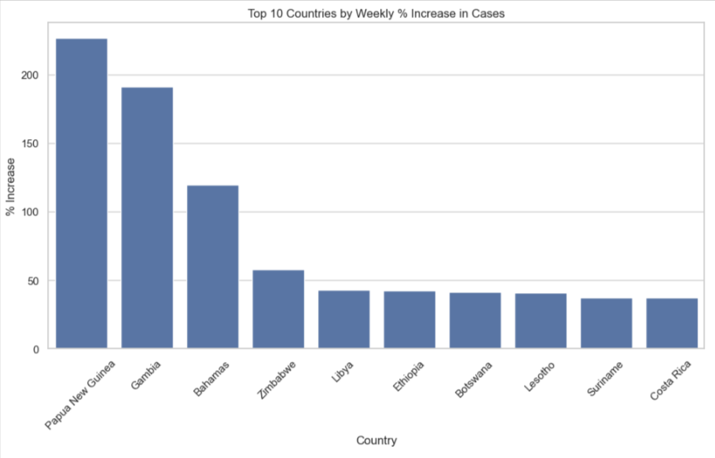
- Papua New Guinea and Gambia have the highest weekly percentage increases in COVID-19 cases, both exceeding 200%. This indicates a rapid surge in cases within a short timeframe, likely reflecting a recent outbreak, increased testing, or changes in reporting.
- Bahamas follow, with percentage increases ranging from 100% to 150%.
- Countries such as Libya, Ethiopia, Botswana, Lesotho, Suriname, and Costa Rica have weekly increases below 50%. Although not as severe, the steady rise still indicates the pandemic's progression in these regions.
Possible Factors Behind the Trends
- Countries with improved or expanded testing may report higher percentage increases as previously undetected cases come to light.
- These trends could reflect localized outbreaks, potentially driven by mass gatherings, reduced restrictions, or poor compliance with public health measures.
- Higher increases might also indicate the inability of some healthcare systems to effectively contain the virus.
Global Metrics: Worldometer Dataset
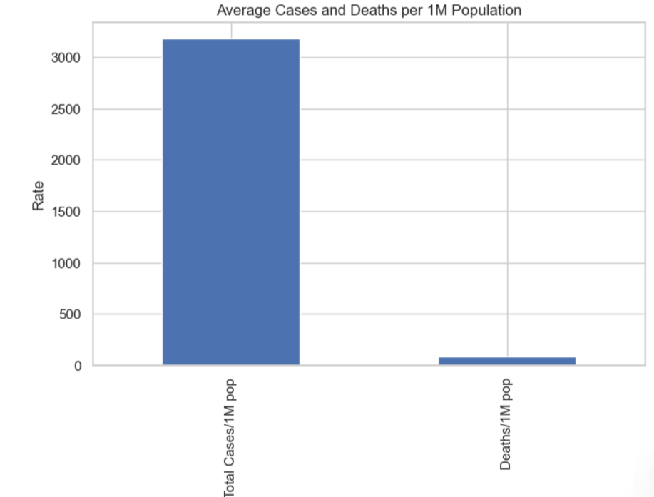
- The average number of Total Cases per 1 Million Population is significantly higher than Deaths per 1 Million Population. This indicates that although a large portion of the population has been infected, the mortality rate (as reflected by deaths) is relatively low.
- The low death rate compared to the number of cases suggests effective medical interventions in some regions, particularly where healthcare infrastructure is robust. A majority of infected individuals have likely recovered, supported by vaccination campaigns and improved treatment protocols.
Country-Specific Trends: Full Group Dataset
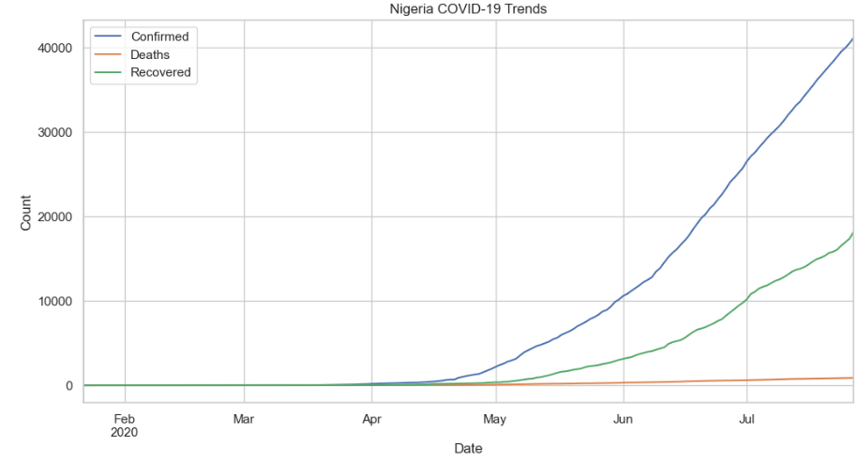

- The confirmed cases (blue line) show a steep rise starting from late April to July 2020, indicating the pandemic's rapid spread within the country. The trend highlights increased testing capacity and/or a rapid transmission rate during this period.
- The recovered cases (green line) also exhibit an upward trend but lag behind the confirmed cases. This is likely due to delays in the recovery process or reporting challenges in real-time.
- The death count (orange line) remains relatively flat compared to the confirmed and recovered cases, suggesting a low fatality rate during this period. This could reflect the young demographic profile of Nigeria, effective treatment strategies, or underreporting of deaths.

Mortality Rates (Deaths / Confirmed Cases)
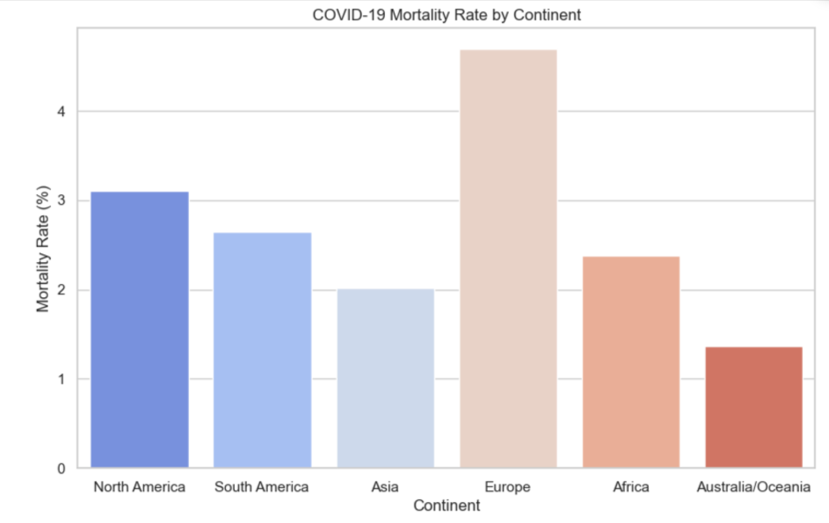
Daily New Cases and Deaths from Daywise Dataset
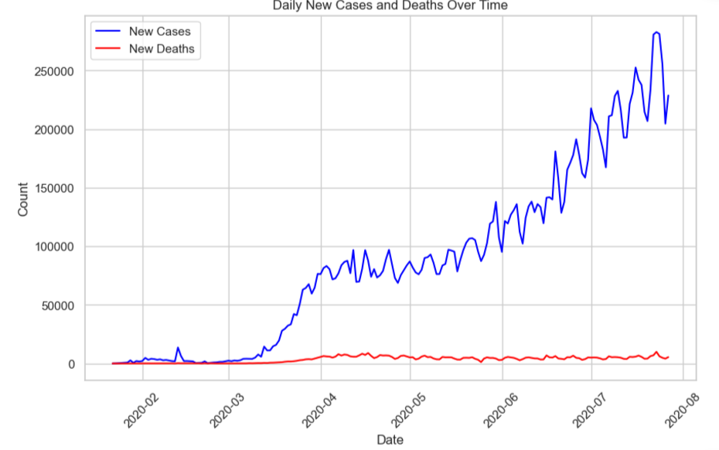
Recovery and Mortality Rates from Daywise Dataset
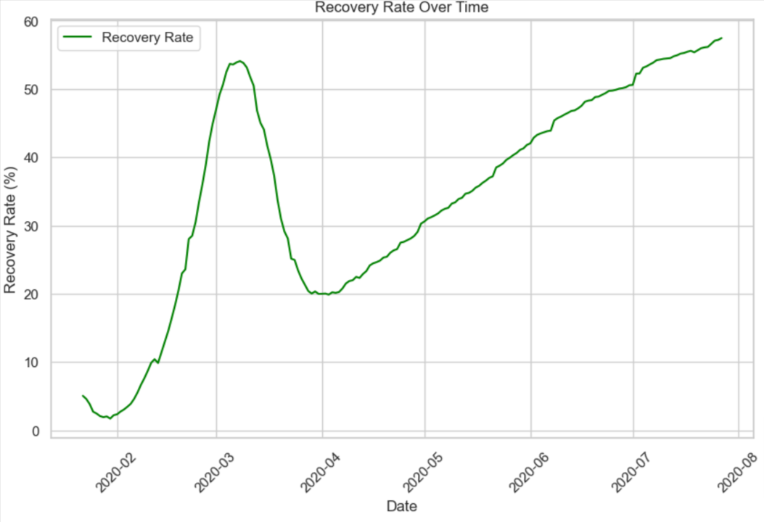
Initial rise in recocery rate (February to Early March 2020)
Possible Causes:
- The early phase of the pandemic might have involved a smaller number of cases with relatively mild symptoms, leading to quicker recoveries.
- Better recovery outcomes could also reflect the initial focus on managing known infections effectively, given the lower burden on healthcare systems at the time.
Sharp peak in recovery rate (March 2020)
- During this period, a significant portion of early infections likely reached resolution (recovery or death). Since recovery typically takes 2–3 weeks, the cases detected in the early stages of the outbreak would have started recovering.
- The sharp peak might also be an artifact of data reporting, where recoveries from previous days were reported in bulk.

Decline in recovery rate (April 2020)
Reasons for the Drop:
- Rising cases: A rapid increase in new cases might have diluted the recovery rate, as recoveries take time, but new cases immediately increase the denominator.
- Strain on healthcare systems: Overwhelmed healthcare facilities could delay recovery times or even affect recovery outcomes.
- Inconsistent reporting or delays in marking patients as "recovered" could temporarily reduce the recovery rate.
Steady and sustained increase in recovery rate (April to August 2020)
- Improved healthcare response: By this period, healthcare systems had better treatment protocols, medications (e.g., remdesivir, steroids), and increased hospital capacity.
- Public health measures: Social distancing, mask-wearing, and other measures reduced the burden on healthcare systems, allowing for better patient outcomes.
- Higher proportion of mild cases: As testing increased, a larger number of mild or asymptomatic cases might have been detected, which naturally recover faster.
- Delayed reporting of recoveries: This phase likely included delayed recovery data from earlier cases, boosting the recovery rate.

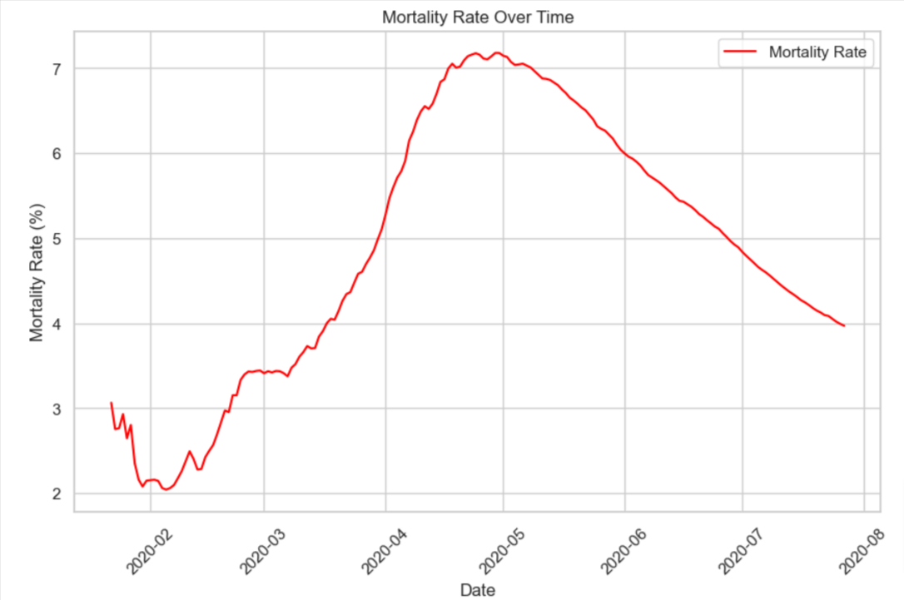
Rise in mortality (February to May 2020)
Possible Causes:
- Initial outbreak and lack of preparedness: The early phase of the COVID-19 pandemic likely saw healthcare systems overwhelmed, with limited knowledge on effective treatment protocols.
- High vulnerability among certain groups: Elderly individuals and those with pre-existing conditions may have been disproportionately affected.
- Testing and reporting limitations: Mortality rates might have been skewed due to underreporting of actual cases, focusing on severe outcomes (hospitalized or deceased cases).
Peak in mortality rate (May 2020)
- This phase reflects the period when the healthcare systems in many regions were at their breaking point. Shortages in critical medical resources such as ventilators, ICU beds, and PPE for healthcare workers likely contributed to higher fatality rates.
Fall in mortality rate (May to August, 2020)
- Improved knowledge and treatment: Over time, healthcare providers developed better treatment protocols, such as the use of steroids (e.g., dexamethasone) and oxygen therapy.
- Increased healthcare capacity: Governments and organizations scaled up hospital infrastructure, testing capacity, and supply chains for essential medical equipment.
- Targeted interventions for vulnerable groups: Protective measures for high-risk populations might have reduced severe outcomes.
- Improved public awareness: Social distancing, masking, and lockdowns may have slowed the spread of the virus, reducing strain on healthcare systems.

- Classification Model Development

- In the image above the classification model library and others were imported.
- The modelling data was prepared by combining unique values in Covid19_clean and full_grouped dataset.
- These were merged together to form the modelling data.
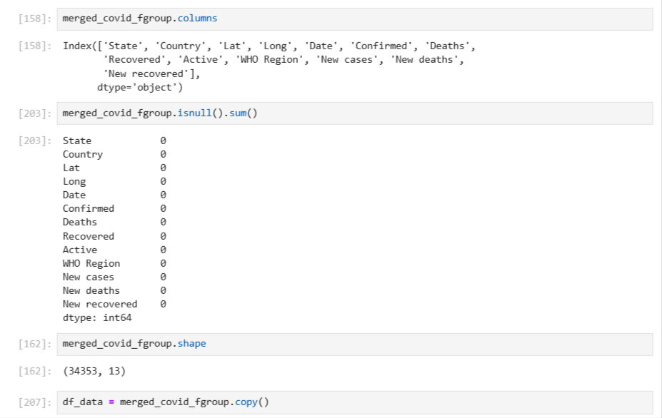
- In this snapshot, the model data was inspected for the columns it contains, the number of rows and columns, and if there are any null values.
- A copy of the model data is then made and named “df_data”

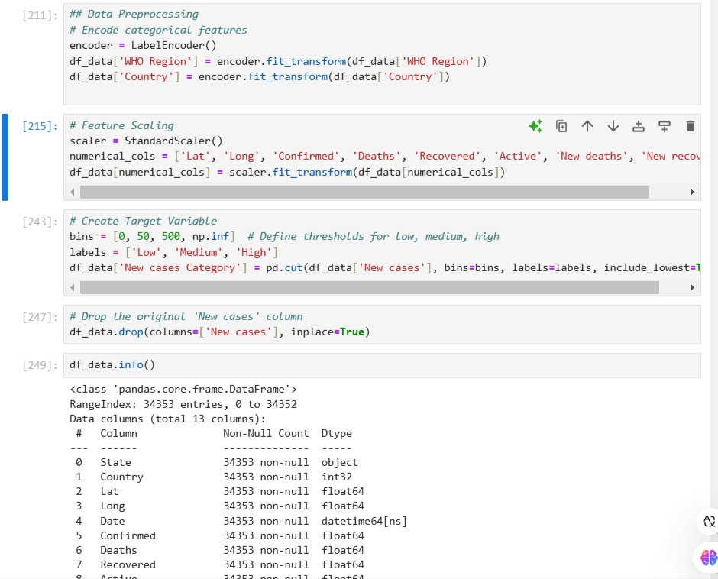
- In this snapshot, the model data was preprocessed by converting categorical columns such as Country and WHO Region into numerical columns using the LabelEncoder method.
- The numerical columns were scaled to eliminate outliers that may skew the data.
- The model will forecast countries with high, medium and low risk cases based on different threshold. This created threshold was named New Case Category.
- The new case column was then dropped.

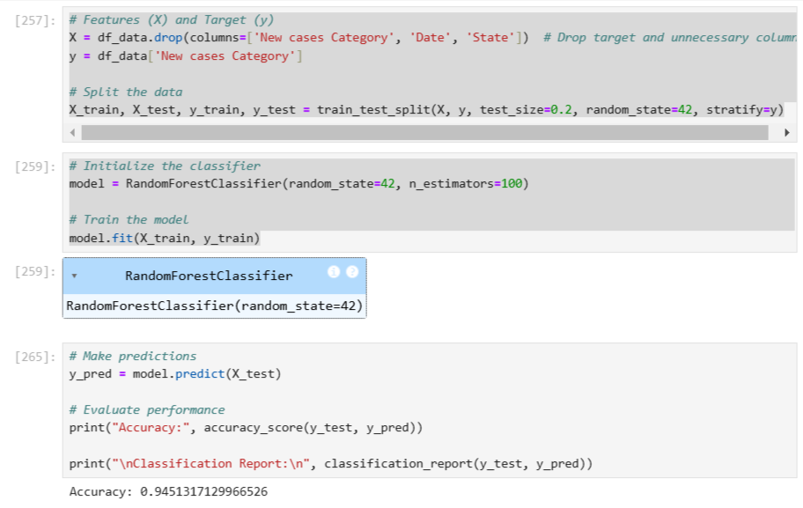
- In this snapshot, the features and targets were defined and the train and test data were also specified. The training data is 80% while test data is 20% of the dataset.
- The model was defined RandomForestClassifier and fitted with the data.
- Prediction were made and it returned an accuracy score of 94.5%, which means the model was able to classify the case as either high, medium or low risk of having a new case of COVID19.

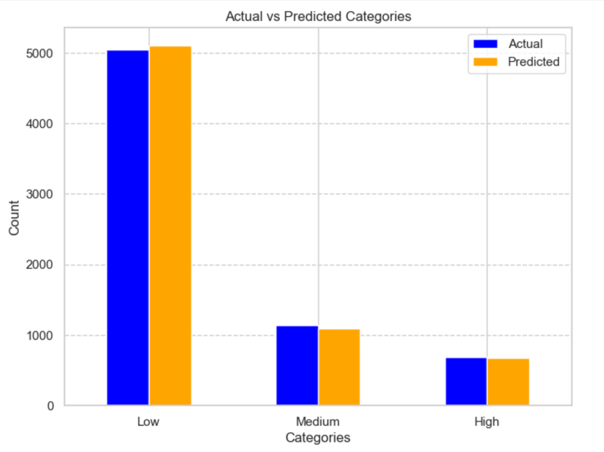
The model was able to classify the dataset as either high risk, medium risk or low risk of COVID19 occurrence very accurate.

